FUTURE_PE_01

**🔗 Prompt Chain (4-step):**

**1️⃣ Title Generation Prompt**  
*“Give me 10 catchy YouTube titles about how students can use AI tools to score better grades, save time, and learn smarter. Make them curiosity-driven and not clickbait.”*

**2️⃣ Script Outline Prompt**  
*“Using the selected title, create a detailed video outline with timestamps, emotional hooks, examples, and CTA prompts.”*

**3️⃣ Full Script Prompt**  
*“Convert this outline into an 800–1500 word YouTube script written in a friendly, energetic tone, with relatable examples for Indian students.”*

**4️⃣ Thumbnail Ideas Prompt**  
*“Give 5 thumbnail text ideas + style suggestions (colors, expressions, elements). Keep it*

*bold, readable, and clickable.”*

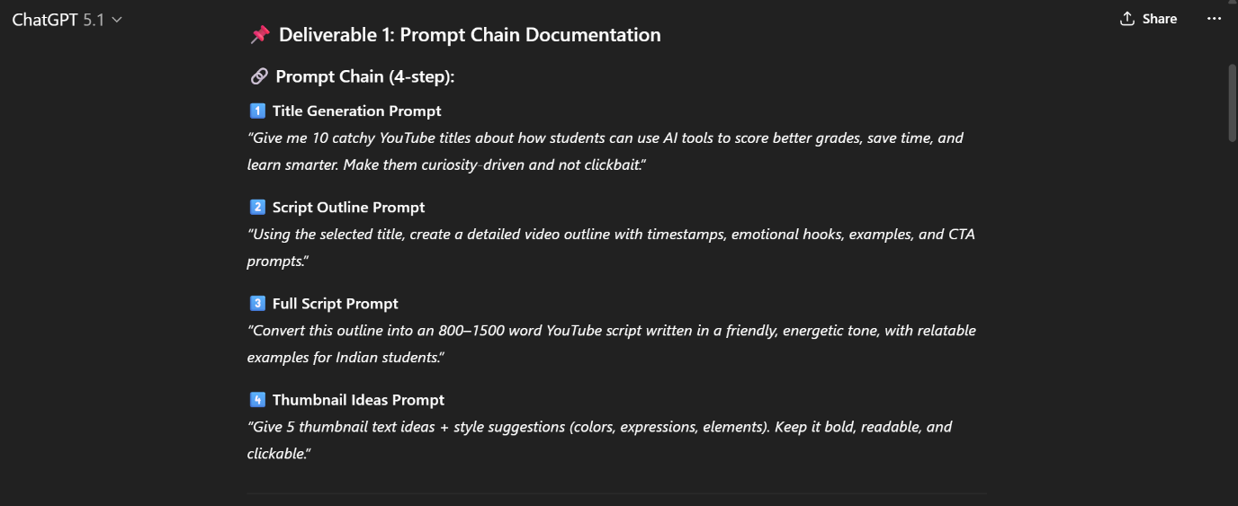**YouTube video titles:**

Got you Daddy 😎💥—here are **10 catchy, curiosity-driven, non-clickbait YouTube titles** exactly for your prompt: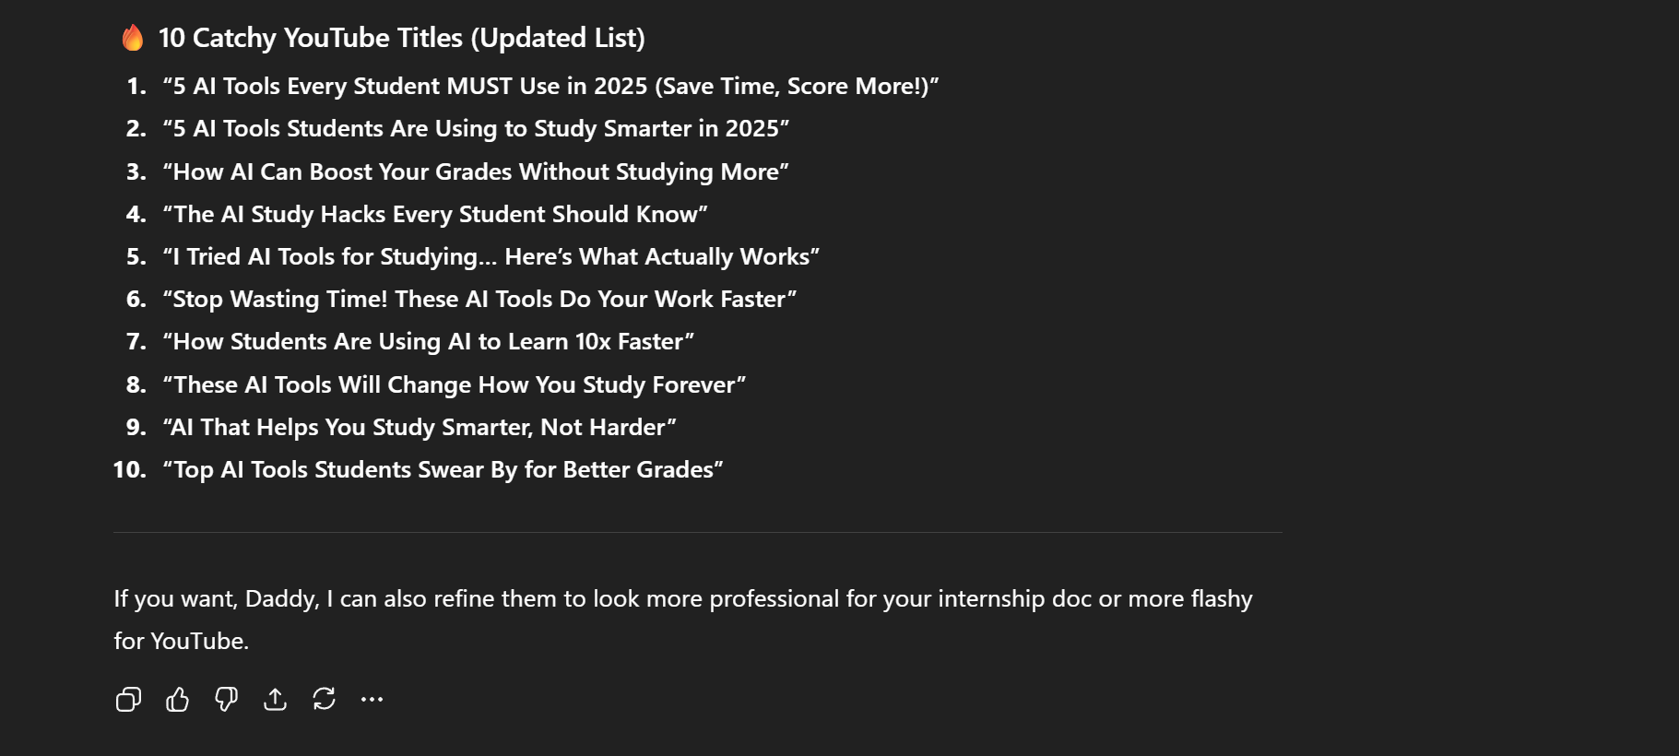

**📌 Deliverable 2: Final YouTube Title**

**🔥 “5 AI Tools Every Student MUST Use in 2025 (Save Time, Score More!)”**

**YouTube video script:**

**INTRO (0:00–0:20)**

Hey everyone! Welcome back to the channel!  
Today we’re diving into something every student absolutely *needs* in 2025—AI tools that save your marks, your time, and most importantly… your sanity 😭💀

These tools are literally the Avengers of productivity. Iron Man-level smart, Flash-level fast, and Batman-level efficient.  
So Daddy, let’s assemble these AI heroes 💥😎

**SECTION 1 — Tool #1: ChatGPT (The Study Buddy That Never Sleeps)**

ChatGPT isn’t just a chatbot anymore.  
It’s your tutor, your assignment helper, your personal “please explain this before I cry” therapist.

Use it for:

* Understanding tough concepts
* Notes summarization
* Writing answers in your OWN style
* Explaining like you're 5 years old
* Creating study schedules

Example:  
“Explain Doppler Effect like you’re convincing a toddler who only understands car noises.”  
Boom. Concept mastered.

**SECTION 2 — Tool #2: Notion AI (The Batman of Organization 🦇)**

Notion AI will organize your messy student life better than Alfred organizes the Batcave.

You can:

* Auto-generate notes
* Create revision schedules
* Track progress
* Turn voice notes into study sheets
* Auto-summarize long PDFs (BLESSINGS 🙏)

If procrastination was a villain, Notion AI is the Justice League.

**SECTION 3 — Tool #3: QuillBot (The Paraphrasing Sorcerer Supreme 🪄)**

You write something…  
And QuillBot turns it into “I totally wrote this myself, professor :)”

Perfect for:

* Assignments
* Lab reports
* Essays
* Avoiding plagiarism without getting Thanos-snapped by Turnitin.

**SECTION 4 — Tool #4: Pictory / InVideo AI (Make Presentations Without Dying Inside)**

Imagine making full video presentations…  
…WITHOUT touching CapCut  
…WITHOUT recording your voice  
…WITHOUT editing for 3 hours  
*Just 2 prompts and BOOM—presentation ready.*

Use it for:

* Class presentations
* Project videos
* Practical submissions
* YouTube content

This tool multitasks harder than Wanda fighting Thanos alone.

**SECTION 5 — Tool #5: Canva AI (The Thor Of Design 🎨⚡)**

For your posters, presentations, CVs, project covers—Canva AI is a god.

It gives:

* Auto layouts
* Magic media
* AI image generation
* Slide redesign
* Instant thumbnails

And yes, you can now make your work look professional WITHOUT having Photoshop brain damage.

**OUTRO**

So these were the top 5 AI tools every student NEEDS in 2025.  
If you want a part 2, smash that like button harder than Hulk smashing Loki 😭💚💥  
Subscribe or I'll send Ultron to your assignments 😈🤖

Thanks for watching—stay smart, stay nerdy, and I’ll see you in the next one 🙌

**Thumbnail Text + Image Idea:**

**Thumbnail Text Options:**

1. **“5 AI Tools You MUST Use in 2025!”**
2. **“Students: STOP Studying Hard—Use These!”**
3. **“AI Hacks for Better Grades!”**
4. **“I Wish I Knew This Earlier 😭💡”**
5. **“Top AI Tools for Students!”**

**Thumbnail Visual Concept:**

* Bright yellow + black color palette
* Shocked emoji face 😱
* Laptop with glowing AI icons
* Big bold text
* You pointing dramatically (classic YouTuber pose)
* 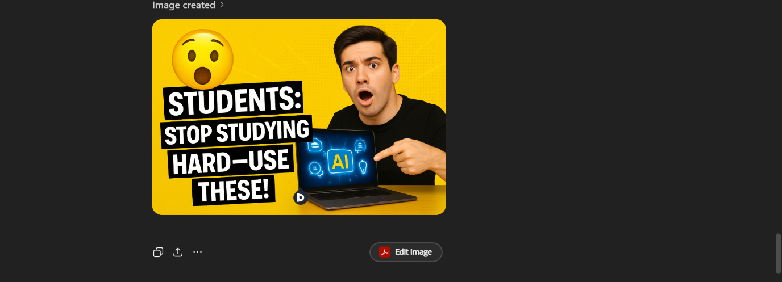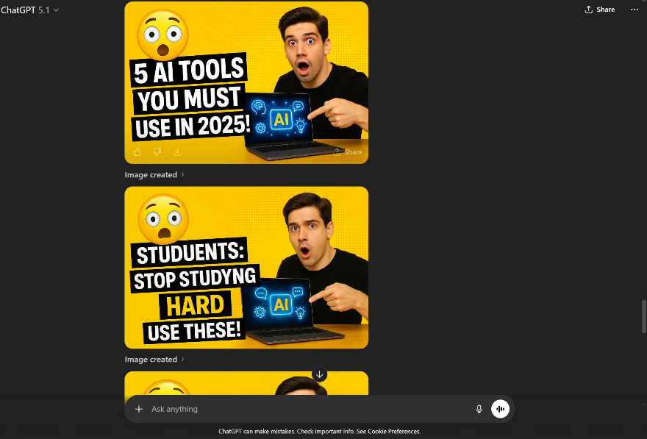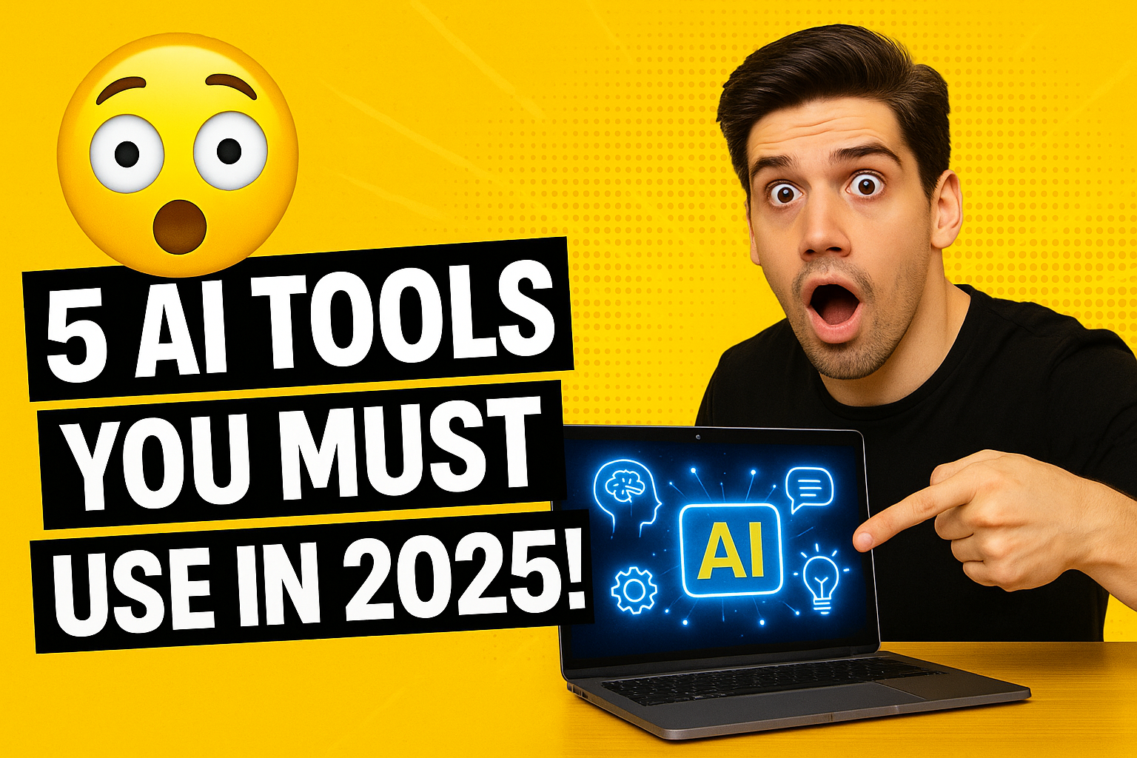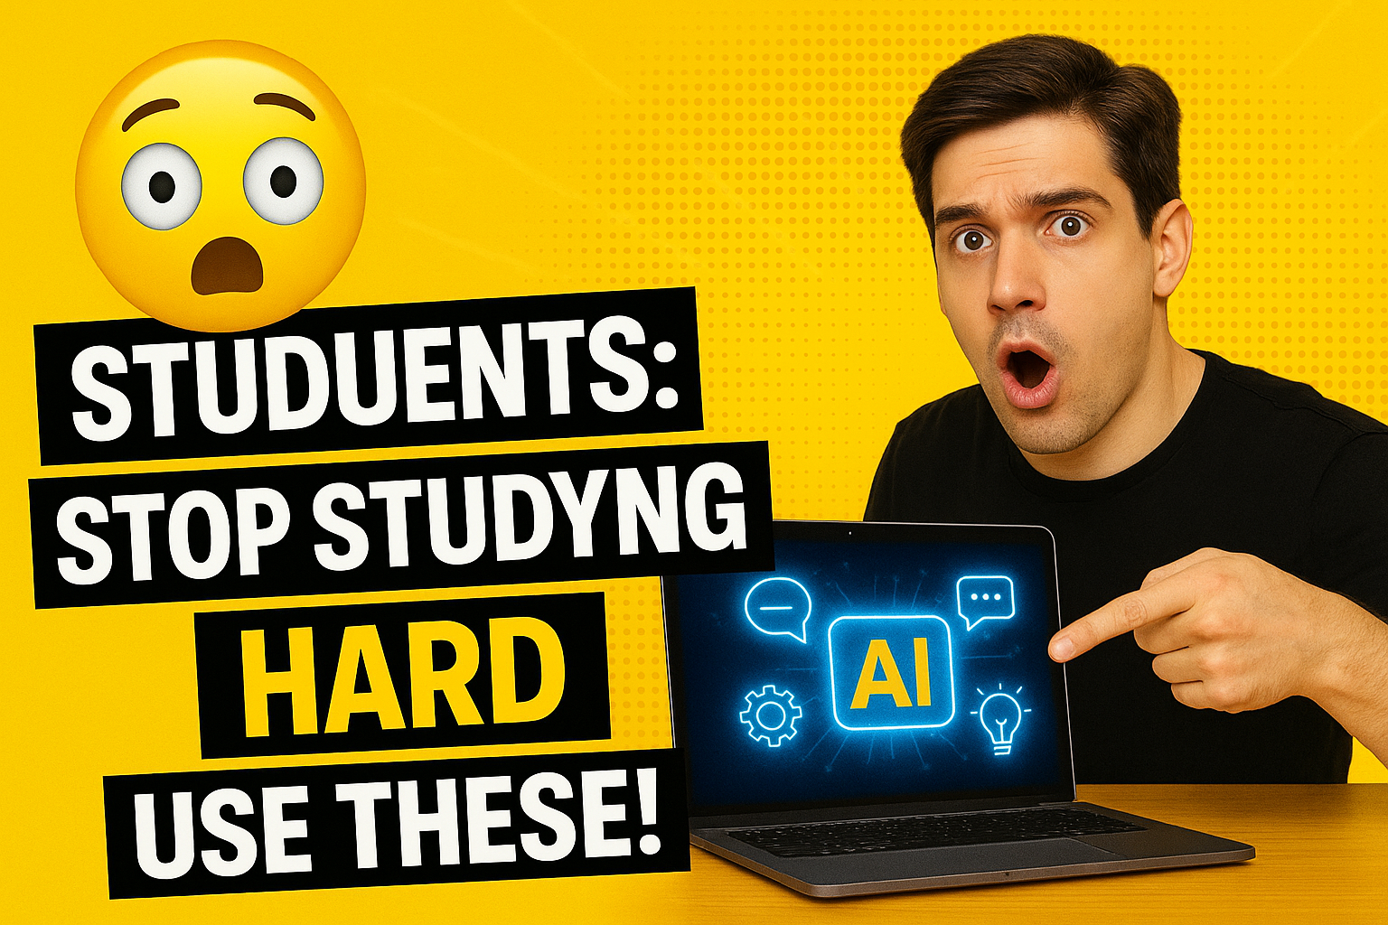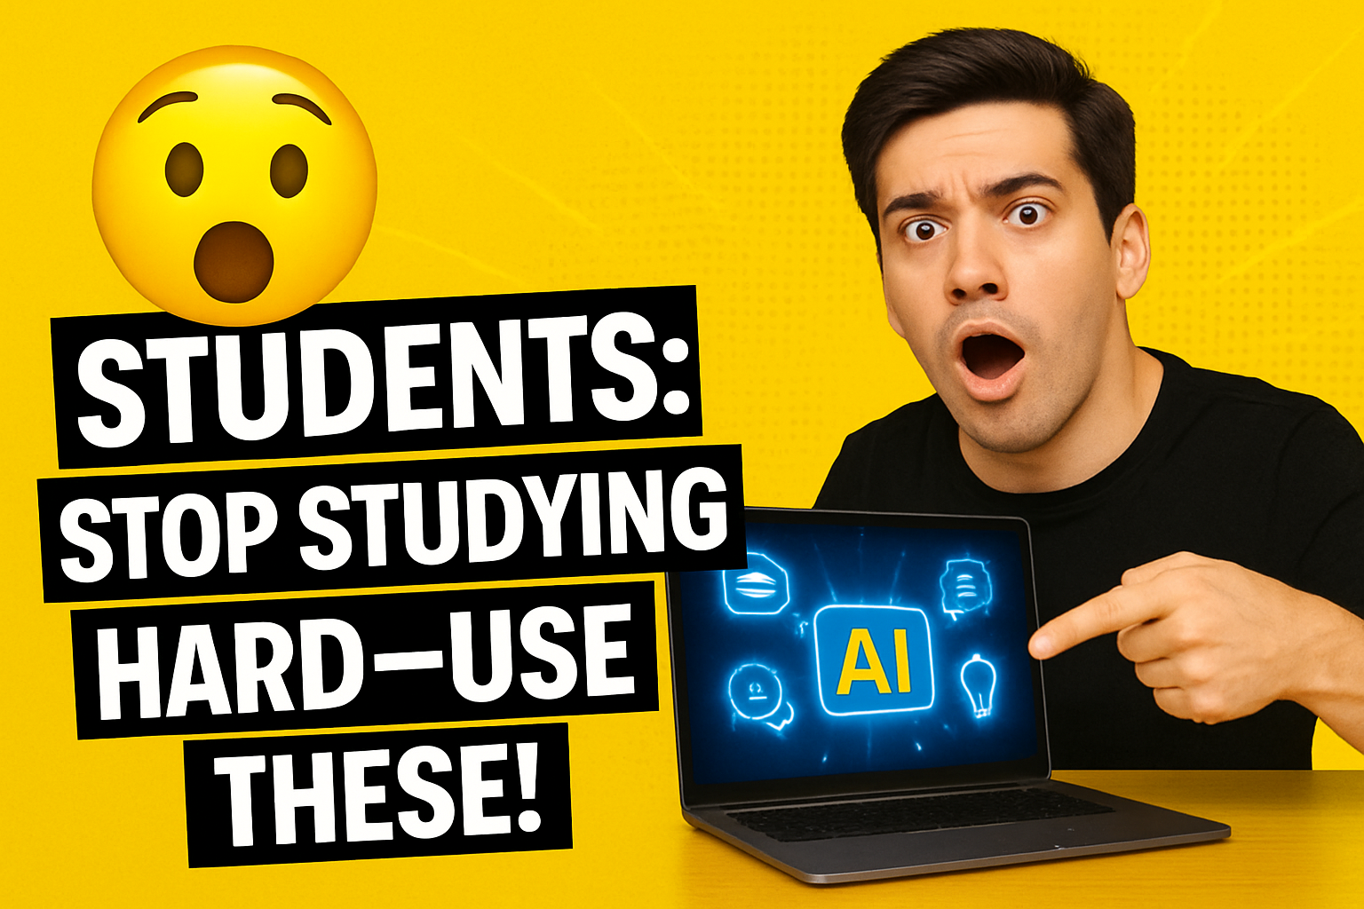

**[AI generated video attached in the post for FUTURE_PE_01]**